**Supplementary Methods**

We extracted the data and R code from the supplementary information in S1 to recreate their analysis. As such we are dependent on the accurate extraction of data from the primary studies by the original authors. We intended our re-analysis of their data to be an example of the cumulative meta-analysis approach rather than to make explicit recommendations about the use of acoustic recorders for avian surveys. Building on their random effects meta-analysis we ran a cumulative meta-analysis using the “cumul” function in the “metafor”S2 package in R. The cumulative meta-analysis was ordered by publication year and plotted using the ggplot2 package in RS3. Where a single study provided more than one estimate of effect the order in which the estimates were accumulated was the same as the order presented by S1 and treated as subsequent trials. Changing the order of that these particular studies were accumulated made no difference to the stability of the estimates over time (see the code for an assessment). The original code, the original data, our additional code for running the analysis and plotting can be found at <https://github.com/DrMattG/Research_waste>.

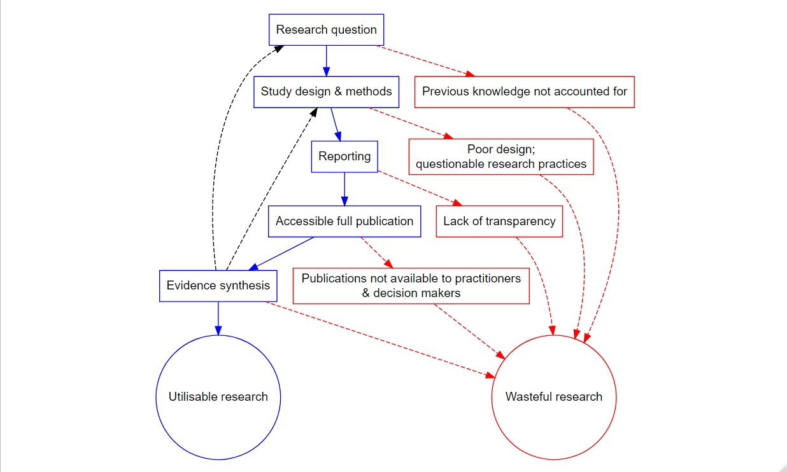

**Supplementary Figure 1** The production of research flows through five stages (blue lines) all of which can lead to research waste(red dashed lines). Ecology and conservation have begun to reduce waste by focusing on methodological improvements and open science. Evidence synthesis (including reporting to decision makers) can contribute to the reduction in research waste by influencing question setting and appropriate methods and design (black dashed lines). Poor evidence synthesis can also lead to research waste.

**Supplementary References**

S1. Darras, K. et al. Comparing the sampling performance of sound recorders versus point counts in bird surveys: A meta-analysis. Journal of applied ecology 55, 2575–2586 (2018).

S2. Viechtbauer, W. Conducting meta-analyses in R with the metafor package. Journal of Statistical Software 36, 1–48 (2010).

S3. Wickham, H. ggplot2: Elegant graphics for data analysis. (Springer-Verlag New York, 2016).